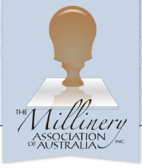
Nomination for Hall of Fame

Nominations are now open for the Hall of Fame for The Millinery Association of Australia which will be presented at the Imaginarium Masquerade Ball at the 2015 Hats Off Convention which will be held at the Hilton Hotel.

The nominee must be a member of the Association and have made an outstanding contribution to Millinery and the Association.

Nominations will close on Monday May 1st.

Submit your nomination by:

E-mail |  | Mail
A PDF version to  admin@millineryaustralia.org | OR | The Secretary Millinery Association of Australia  P.O. Box 184  West Brunswick Vic 3055

Name of Nominee: | Click here to enter text.
Reason for Nomination | Click here to enter text.
Your name: | Click here to enter text.
Contact number: | Click here to enter text.
E-mail address: | Click here to enter text.

