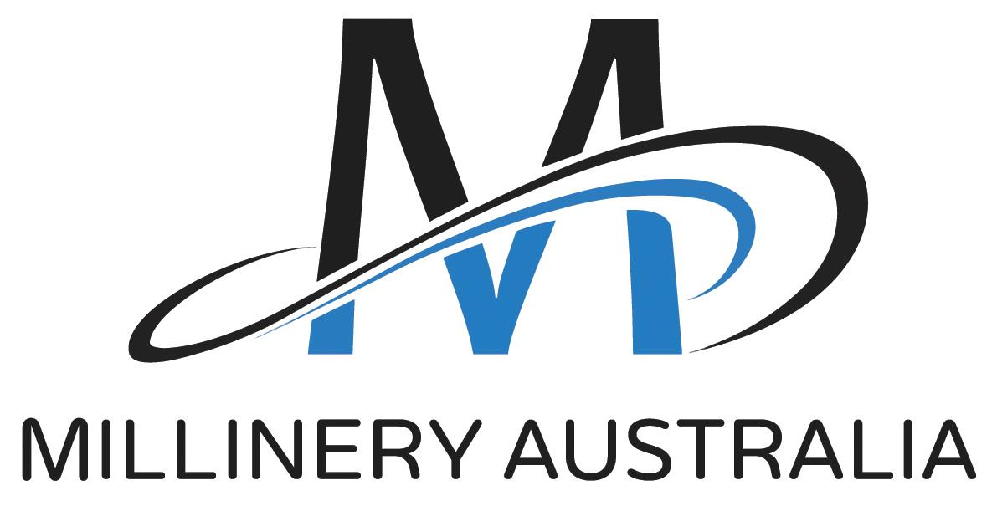
Millinery Australia
Sponsorship/Funding Application

CONTACT DETAILS
Name
Organisation/Business Name
ABN
Address
Email
Mobile

THE PROJECT
PROJECT TITLE
PROJECT OVERVIEW | Please provide a 50 word summary of your project.
MAA FOCUS ACTIVITIES | How does your project address one or more of these activities?  (max. 200 words)  - Opportunities for milliners to showcase their design and technical skills  - Professional development that encourages milliners to strengthen technical knowledge & skills  - Opportunities to raise the profile of milliners and millinery
IMPLEMENTATION PLAN | Please provide a brief implementation plan that notes key project activities and timings.
BUDGET & SPONSORSHIP REQUEST | Please provide a brief project budget noting both cash and any in-kind support requested from MAA.
SPONSORSHIP BENEFITS | Please note all sponsorship benefits you will provide to MAA.  e.g. logo placements, feature articles, display banner at event, MAA speaker/presenter/judge, social media posts
MEASURES & TARGETS | For each of the following measures relevant to your project, please note your target  - No. of project participants e.g. individual entrants, attendees  - No. of MAA members participating in project  - Feedback from participants (both MAA & non-MAA members)  - No. of quality promotional opportunities  - No. of new successful MAA membership applications  How will you track progress against your targets?
For Signature | The information in this application is true and correct.  I understand that if my application is successful, I will receive a letter confirming the scope and terms of any MAA sponsorship.  Name:  Date:

Thank you for completing this application form.
Please submit this form to: treasurer@millineryaustralia.org

The Millinery Australia Committee will review you application and be in contact if further information is needed.

