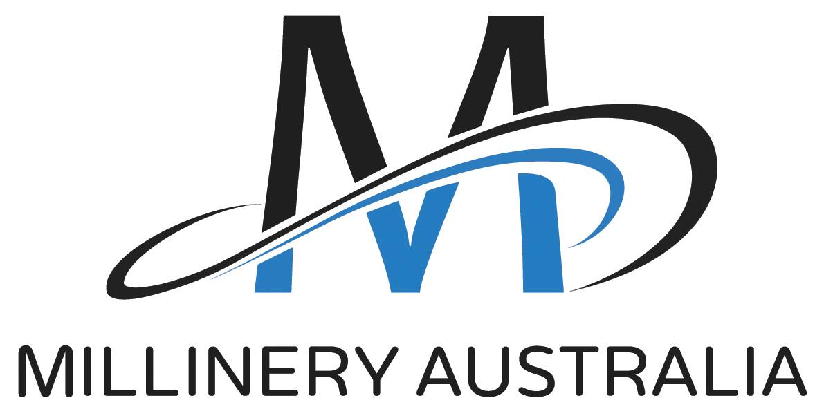
2022 Design Award
Hat Information Form

ENTRANT NAME:

BUSINESS NAME:

WEBSITE ADDRESS:

LOGO
Please email your logo as a jpeg file to: designaward@millineryaustralia.org

HAT NAME:

MATERIALS USED:
Please list the main materials used in your entry.

ARTIST STATEMENT (approx. 80 words)
Please tell us about your your entry e.g. inspiration, connection with the competition theme ‘Counter Balance’, techniques used

BIOGRAPHY (approx. 50 words)
Please tell us about you.

ENTRY CHECKLIST:
In your box
- the entered hat or headpiece
- a printed copy of this form
- an A4 page showing front and back views of how the hat should be worn on a mannequin head
- a return address label

Via email to designaward@millineryaustralia.org
- a copy of this form
- your logo

