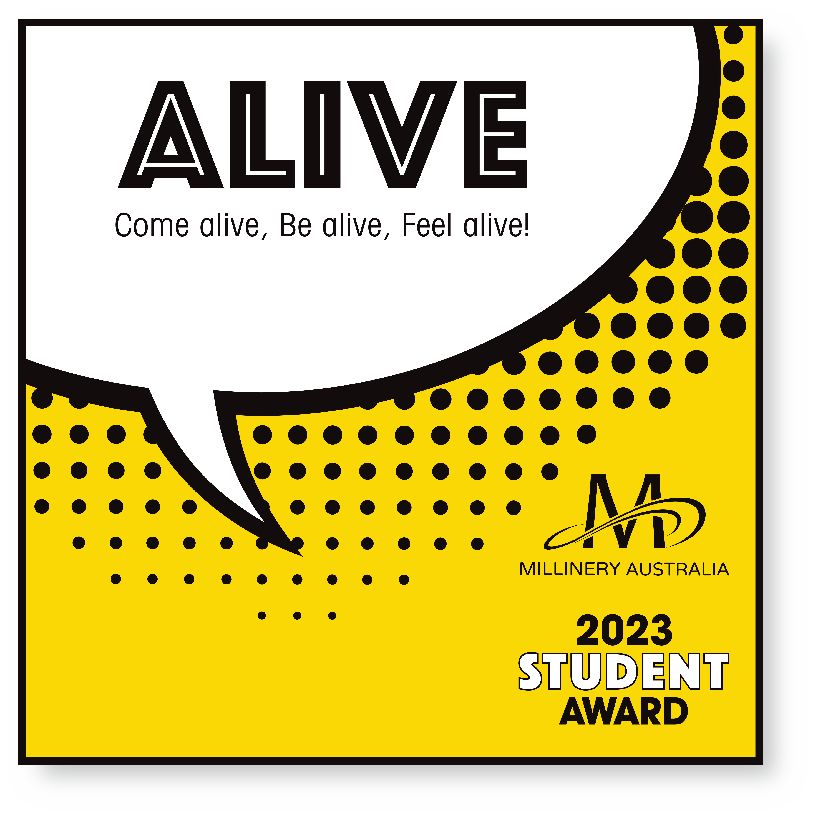

2023 Student Award
Hat Information Form

ENTRANT NAME:
HAT NAME:
MATERIALS USED:
Please list the main materials used in your entry.
ARTIST STATEMENT (approx. 80 words)
Please tell us about your entry e.g. inspiration, connection with the competition theme ‘ALIVE’, techniques used
BIOGRAPHY (approx. 50 words)
Please tell us about you.
MILLINERY CLASSES
What Millinery Classes have you undertaken in the last 12 months?

ENTRY CHECKLIST:
In your box
- the entered hat or headpiece
- a printed copy of this form
- an A4 page showing front and back views of how the hat should be worn on a mannequin head
- a return address label

Via email to studentaward@millineryaustralia.org
- a copy of this form as a word document

